**Firewall rules for mongodb port opening**

**Firewall connection security rules for mongodb**

After inserting inbound and outbound rule we need to add connection security rule.

Click on Connection Security Rules as per below snapshot.

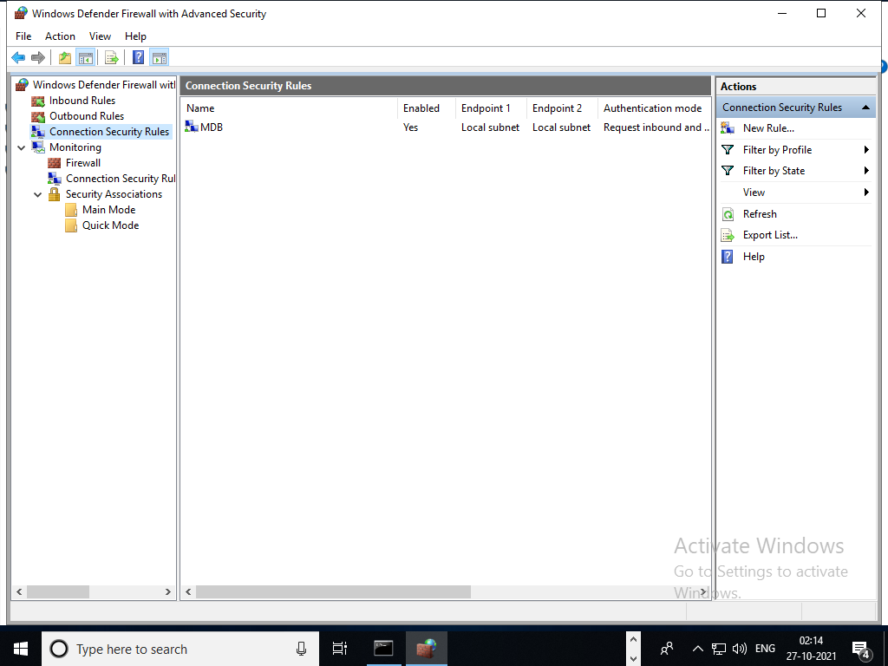

Add Protocol type as “TCP”, Endpoint 1 port as “All Ports”, Endpoint 2 port as “All Ports”

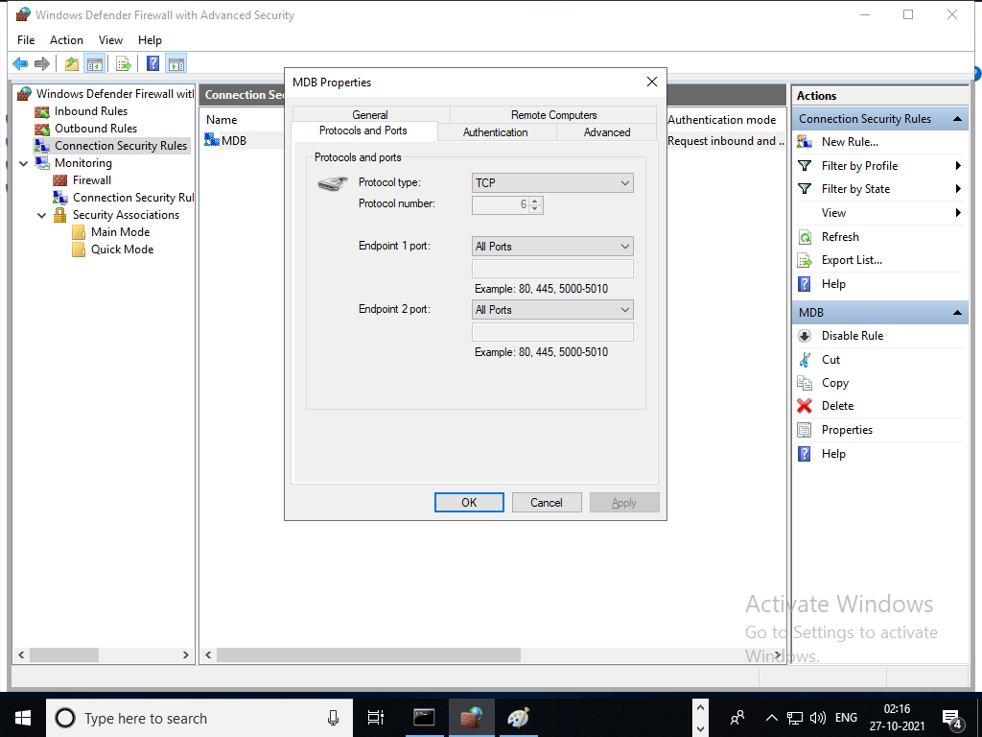

Add Endpoint 1 and Endpoint 2 as “Local subnet”

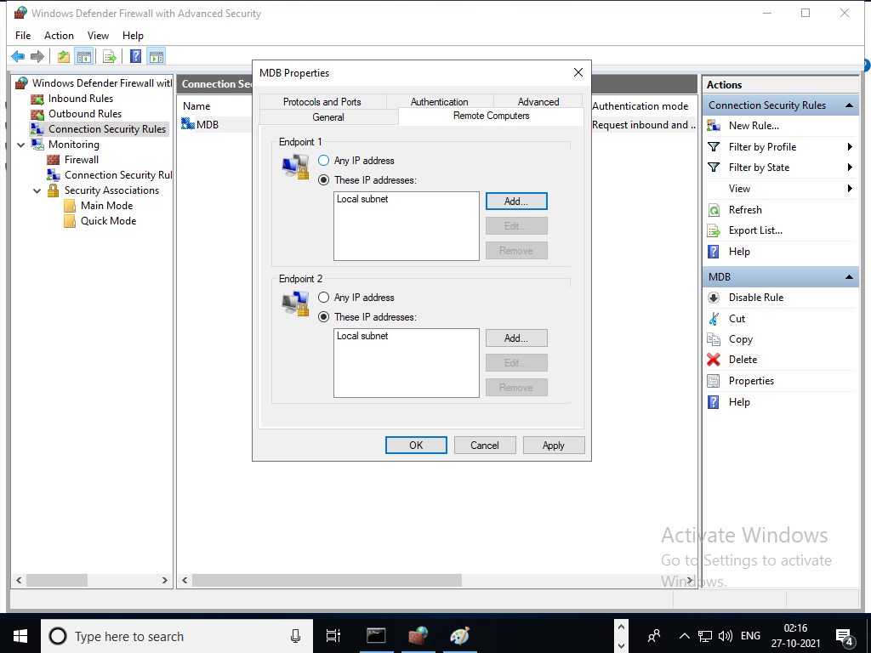

Select Authentication mode as “Request inbound and outbound” and method as “Default”

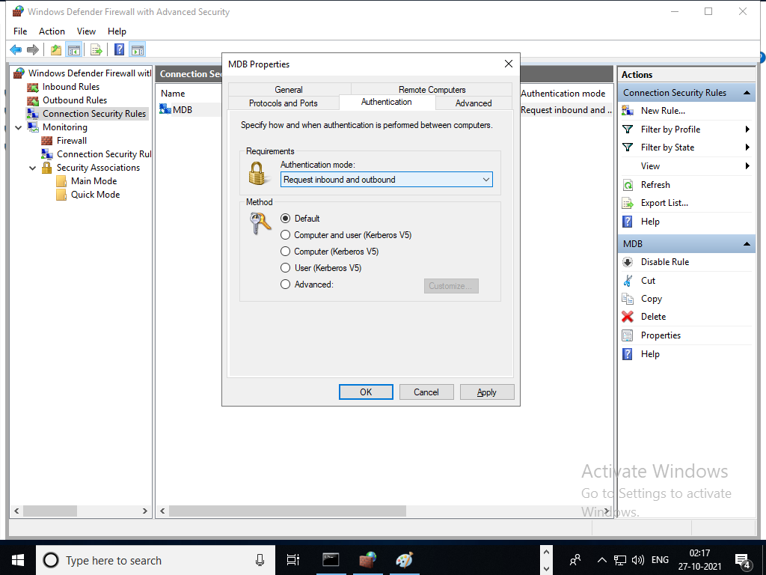

Select specify profiles to which this rule apply in “Domain , Public and Private”

